## REST API (REST stands for REpresentational State Transfer)

MILESTONE 1

API stands for Application Programming Interface, and unfortunately, people will ask you the meaning of each word here. An API is like a waiter in a restaurant. You don’t go into a cafe and walk straight into the kitchen to tell the chef what you wanna eat. The waiter does that for you, and that’s exactly what an API is - with the client being you, the customer and any resource that can send data, being the chef.

Now, these APIs have different styles, or in more formal terms - conventions and architectures about how they are used.

REST APIs are those APIs which follow the guidelines set by the REST architecture. They follow a client-server model where one software program sends a request and the other responds with some data. REST APIs commonly use the HTTP protocol to send requests & receive responses.

How an API request differs from a usual HTTP request for a webpage, is in terms of the data returned. HTTP requests for webpages return HTML, CSS & JavaScript files which are rendered by the browser and displayed to the user. But, in the case of APIs, the request can be for any data (not just webpage) and the response is read by the requesting program which interprets the data.

JSON (JavaScript Object Notation ) is a standard format that is easily "understandable" by applications and can be handled well in most languages. So the data format in REST is usually JSON. For example, an Android app can effortlessly utilize data sent by a Node.js server. XML is another popular format for data transfer between applications.

The APIs might require authentication when you try it out (Authentication is done so that a spammy bot(aka, hacker) doesn’t send ten quadrillion requests to a resource and blast its servers out. It can be caught and stopped)

REST API calls are made on top of the HTTP protocol. We can analyse the network packets during the API calls to confirm this using Wireshark.  
**Wireshark** is a popular network analysis tool to capture network packets and display them at a granular level. Once these packets are broken down, you can **use** them for real-time or offline analysis.

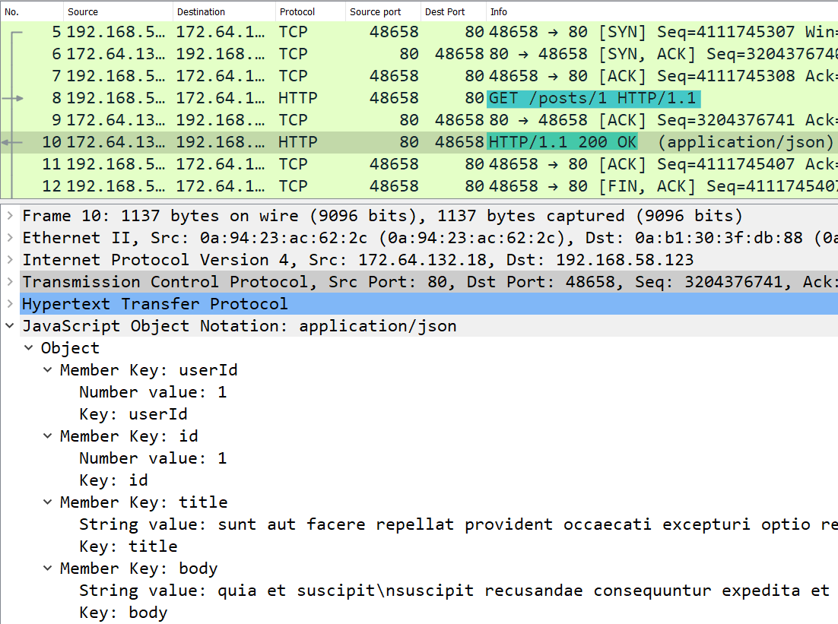

 REST is one architectural pattern used, NOT the only one. There are some has beens, like SOAP and some new kids on the block, like GraphQL. These patterns differ in the ways in which they ask for data, send data, and how they enforce these practices.

1. [Understanding & using REST APIs](https://www.smashingmagazine.com/2018/01/understanding-using-rest-api/" \t "https://learn.crio.do/home/me/ME_REST/_blank)
2. [HTTP vs REST](https://restishistory.net/blog/do-you-know-the-difference-between-http-and-rest.html" \t "https://learn.crio.do/home/me/ME_REST/_blank)
3. [REST Guidelines](https://restfulapi.net/" \t "https://learn.crio.do/home/me/ME_REST/_blank)
4. [Metaweather API Documentation](https://www.metaweather.com/api/" \t "https://learn.crio.do/home/me/ME_REST/_blank)
5. [Installing Wireshark on Ubuntu](https://itsfoss.com/install-wireshark-ubuntu/" \t "https://learn.crio.do/home/me/ME_REST/_blank)
6. [Capturing HTTP network packets using Wireshark](https://en.wikiversity.org/wiki/Wireshark/HTTP" \t "https://learn.crio.do/home/me/ME_REST/_blank)

MILESTONE 2. ANATOMY OF REST API

#### **Components of a REST API Request**

Request URL: [https://www.metaweather.com/api/location/search/?query=san](https://www.metaweather.com/api/location/search/?query=san" \t "https://learn.crio.do/home/me/ME_REST/_blank)

Request Method: GET which denotes the type of HTTP request made. GET means data needs to be fetched.

Request Headers: eg: accept, accept-encoding - used to send additional info like the type of encoding that the requesting application (browser) supports

Request Body: is empty for the current request but can be used for sending additional information like a file’s content when uploading it to the server.

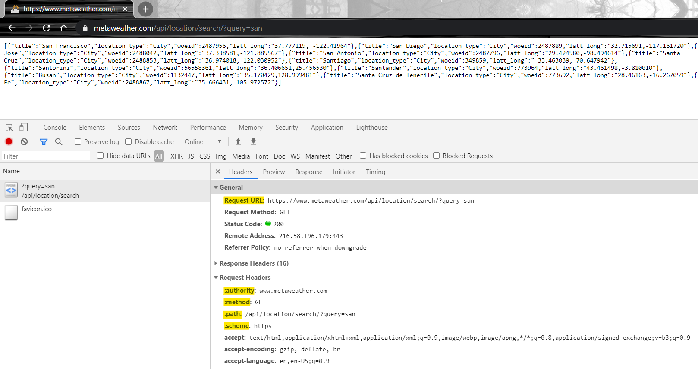

The Request URL is made up of the

1. Scheme: https - denotes the request was made using the HTTPS protocol ie, secure version of the HTTP protocol
2. Root-endpoint: www.metaweather.com - defines the API provider
3. Path: /api/location/search/ - there will be one api path for each type of resource. Here, we are asking for the resource named location.
4. Query parameter: ?query=san - the part of the URL that comes after a ? character is the query parameter. It specifies the search criteria for the resource. Here, the locations returned get filtered by the value of the query parameter, query we provide.

References

[Using DevTools to inspect network activity](https://developers.google.com/web/tools/chrome-devtools/network" \t "https://learn.crio.do/home/me/ME_REST/_blank)

[Understanding And Using REST APIs](https://www.smashingmagazine.com/2018/01/understanding-using-rest-api/" \t "https://learn.crio.do/home/me/ME_REST/_blank)

#### MILESTONE 3 : **REST API calls using Programs**

Use curl on your command line to make a REST API call to [https://www.metaweather.com/api/location/search/?query=san](https://www.metaweather.com/api/location/search/?query=san" \t "https://learn.crio.do/home/me/ME_REST/_blank). This fetches location information for locations matching the **query** parameter san

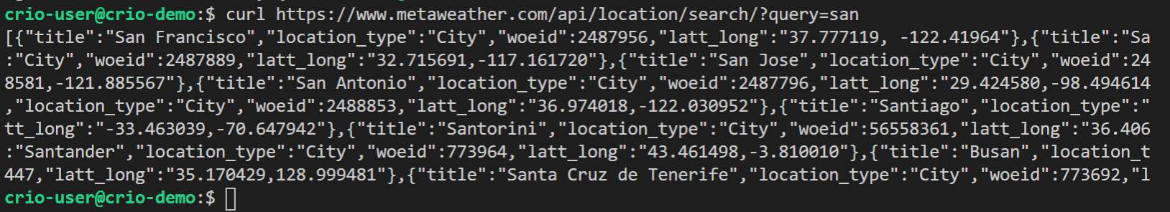

Using python program to call rest api

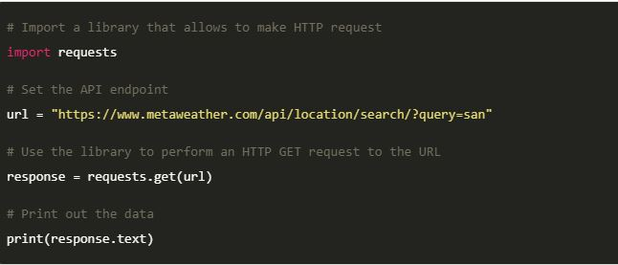

JAVA program to do the same

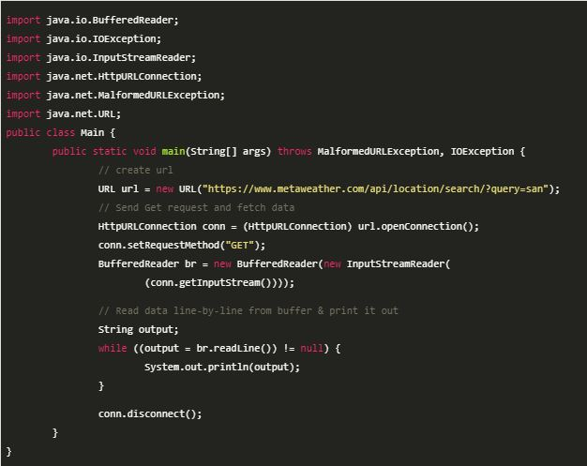

**MILESTONE 4** : **TO POST ON LINKEDIN USING cURL COMMAND**

----> YOUTUBE : HTTP VIDEO

**MILESTONE 5** : **SUMMARY**

APIs makes it easier for :

Applications to expose their services

Other applications to avail those services.

Integration is easier, only the API definitions need to be exposed.

**Further Reading**

[Generating Code Snippets using Postman](https://learning.postman.com/docs/sending-requests/generate-code-snippets/" \t "https://learn.crio.do/home/me/ME_REST/_blank)

Right way to design REST URL [Best Practices 1](https://florimond.dev/blog/articles/2018/08/restful-api-design-13-best-practices-to-make-your-users-happy/" \t "https://learn.crio.do/home/me/ME_REST/_blank) and [Best Practices 2](https://medium.com/@mwaysolutions/10-best-practices-for-better-restful-api-cbe81b06f291" \t "https://learn.crio.do/home/me/ME_REST/_blank)

[5 Basic REST API Design Guidelines](https://blog.restcase.com/5-basic-rest-api-design-guidelines" \t "https://learn.crio.do/home/me/ME_REST/_blank)

[REST vs GraphQL APIs, the Good, the Bad, the Ugly](https://www.moesif.com/blog/technical/graphql/REST-vs-GraphQL-APIs-the-good-the-bad-the-ugly/" \t "https://learn.crio.do/home/me/ME_REST/_blank)

[SOAP vs REST](https://www.upwork.com/resources/soap-vs-rest-a-look-at-two-different-api-styles" \t "https://learn.crio.do/home/me/ME_REST/_blank)

**Interview Corner**

What’s REST and how it differs from GraphQL?

What’s an API, how do you ‘hit’ an API? How do you query APIs?

What are three things you’ll keep in mind when creating a REST API?

# Pointers to Curious Cats Questions

## Milestone 1

### Are the API endpoints case sensitive i.e, if requests to /location & /Location must return the same response? Try it out for <https://www.metaweather.com/api/location/search/?query=san>

The case-sensitivity of endpoints isn’t a constraint that REST imposes but comes up because we’re using HTTP for communication. For HTTP, the scheme & hostname are case-insensitive and the rest of the part is case-sensitive (for <https://www.metaweather.com/api/location/search/?query=san> scheme is *https* and hostname is [www.metaweather.com](http://www.metaweather.com))

### Why is it that you are able to make a REST API call via the browser?

Like we discussed, REST API calls are made on top of HTTP requests. Browsers as we know can make HTTP requests (they can visit web pages, right?) and hence can also make REST API calls that are made via HTTP, as long as they can interpret the data that is received in the response.

## Milestone 2

### Let’s say we need to use another parameter, country along with the query parameter to filter the locations for a particular country. How would we redesign the request URL, https://www.metaweather.com/api/location/search/?query=san for this purpose?

Search parameters come after the **?** character. Multiple search parameters can be used by separating them with the **&** character.

<br>

For an API that needs to take two search parameters - **query(city)** and **location (country),** the request URL should be like this <https://www.metaweather.com/api/location/search/?query=san&location=India>

## Milestone 3

### Try doing a POST request for  https://www.metaweather.com/api/location/search/?query=san. What is the status code of the response received?

HTTP 405 response code is returned as the endpoint only allows GET request. We can use the curl command to send a POST request. You can try [this](https://reqbin.com/curl) online curl utility

curl -X POST https://www.metaweather.com/api/location/search/?query=san

